APR 2026 version

ID:
Joint-Directed Immunomodulatory Low-Dose Radiation Prescription for Arthritis
BEAM | PATELLAR (Field 1) | PLOPLITEAL (Field 2) | LATERAL (Field 3) | MEDIAL (Field 3)
Site | KNEE
Laterality | LEFT
Verified Rx in Sensus EMR
Cumulative dose per course | 3 Gy/course (300 cGy/course) prescribed to midplane
Dose per FRACTION | 0.50 Gy/fx | ( 50 cGy/fx) prescribed to midplane
Cumulative dose per Beam | 1.5 Gy per beam | 1.5 Gy per beam | 1.5 Gy per beam | 1.5 Gy per beam
Beam Waiting | 50% | 50% | 50% | 50%
Dose per fraction per beam | 0.25 Gy per fraction per beam | 0.25 Gy per fraction per beam | 0.25 Gy per fraction per beam | 0.25 Gy per fraction per beam
Time (minutes)
Total Fraction no. | 6 fractions | 6 fractions | 6 fractions | 6 fractions
SSD w/in applicator | 10 cm applicator - 25 cm SSD | 10 cm applicator - 25 cm SSD | 10 cm applicator - 25 cm SSD | 10 cm applicator - 25 cm SSD
SSD lid | Lead - 1 cm SSD | Lead - 1 cm SSD | Lead - 1 cm SSD | Lead - 1 cm SSD
SSD (cm) within box
Caliper Measurement
Total SSD (cm) | _cm (box) + _cm (lid) + _ cm (applicator) =_ cm | _cm (box) + _cm (lid) + _ cm (applicator) =_ cm | _cm (box) + _cm (lid) + _ cm (applicator) =_ cm | _cm (box) + _cm (lid) + _ cm (applicator) =_ cm
Energy | 100 kV  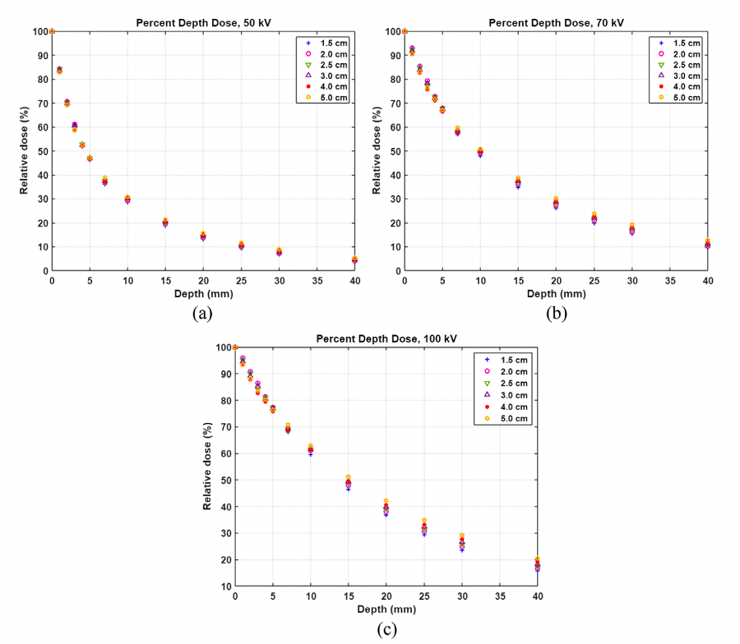 | 100 kV   | 100 kV   | 100 kV  
Extended SSD  Reference Data | 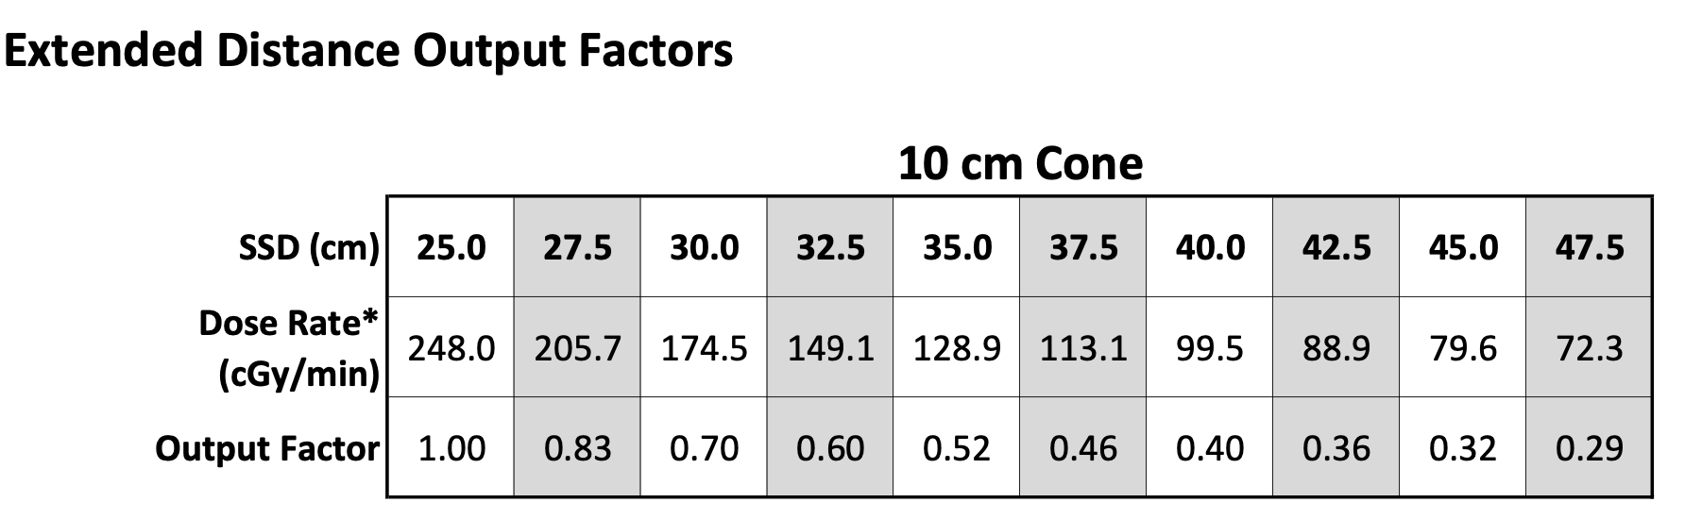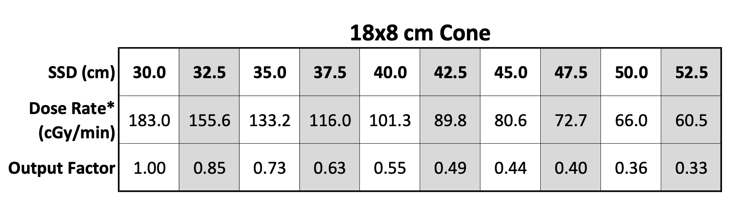
Corrected Dose Calculation
Applicator size | 18 x 8 cm | 18 x 8 cm | 18 x 8 cm | 18 x 8 cm
Margin | mm | mm | mm | mm
Technique | Superficial XRT | Superficial XRT | Superficial XRT | Superficial XRT
Lead Shield #1 Size
Lead Shield #2 Size
Lead Shield #3 Size
Thyroid Shield | YES | YES | YES | YES
Lead Apron | YES | YES | YES | YES
Nasal Bullet | None | None | None | None
Eye Shield Interior | None | None | None | None
Eye Shield Exterior | None | None | None | None
Lead Glasses | YES | YES | YES | YES
Dose Rate | per plan | per plan | per plan | per plan
Beam Arrangement | En Face Kilovoltage Photons | En Face Kilovoltage Photons | En Face Kilovoltage Photons | En Face Kilovoltage Photons
Technique | Depth-Enabled Epidermal Sparing Superficial XRT | Depth-Enabled Epidermal Sparing Superficial XRT | Depth-Enabled Epidermal Sparing Superficial XRT | Depth-Enabled Epidermal Sparing Superficial XRT
Beam Weighing | % | % | % | %
Fractions per day | 1 | 1 | 1 | 1
Fractions per week | 2 or 3 | 2or 3 | 2 or 3 | 2or 3
Single or Multi phase/beam | Single Phase  Multibeam | Single Phase  Multibeam | Single Phase  Multibeam | Single Phase  Multibeam
Synchronous vs Sequential | Sequential | Sequential | Sequential | Sequential
Plan Type | 2DCRT - Clinical Setup | 2DCRT - Clinical Setup | 2DCRT - Clinical Setup | 2DCRT - Clinical Setup
Beam Arrangement | APPA
Imaging | Daily X-ray: 100 kV w/ filter and treatment shield in place (for image guidance) | Daily X-ray: 100 kV w/ filter and treatment shield in place (for image guidance) | Daily X-ray: 100 kV w/ filter and treatment shield in place (for image guidance) | Daily X-ray: 100 kV w/ filter and treatment shield in place (for image guidance)
Image-guidance Code | 77387 X-ray Guidance | 77387 X-ray Guidance | 77387 X-ray Guidance | 77387 X-ray Guidance
Alignment | Align field visually  Confirm radiographically | Align field visually  Confirm radiographically | Align field visually  Confirm radiographically | Align field visually  Confirm radiographically
In Vivo Dosimetry/Film  (77331) | YES | YES | YES | YES
**GRID | NO | NO | NO | NO
**Concurrent Therapy | NO | NO | NO | NO
**Pre-Authorized | NA | NA | NA | NA
SIM ORDER Drawn Target on RADIOGRAPH

(Sim order photos with margins drawn by RadOnc)

Sim Image: Inked Target
Sim Image: Side nozzle view
Boxtop:
Beam’s Eye View
SSD photographs

Image-Guidance DICOM
Radiograph as seen in PACS

Electronically Signed by: | Clayton B. Hess, MD, MPH  Radiation Oncologist
Date Ordered: | Mar 31, 2026

FEB 2026 version

ID:
Joint-Directed Immunomodulatory Low-Dose Radiation Prescription for Arthritis
BEAM | PATELLAR (Field 1) | PLOPLITEAL (Field 2) | LATERAL (Field 3) | MEDIAL (Field 3)
Site | KNEE
Laterality | LEFT
Consult Images
Caliper Measurement (relevant to beam angle) | _cm  Photo | _cm  Photo | _cm  Photo | _cm  Photo
SIM ORDER Drawn Target on RADIOGRAPH

(Sim order photos with margins drawn by RadOnc)

Sim Image: Inked Target
Sim Image: Size nozzle view
Boxtop:
Beam’s Eye View
Light field showing smallest SSD to fit shield

Image-Guidance DICOM
Radiograph as seen in PACS

Verified Rx in Sensus EMR
Energy | 100 kV   | 100 kV   | 100 kV   | 100 kV  
Dose per PHASE | Gy | (cGy) | Gy | (cGy) | Gy | (cGy) | Gy | (cGy)
Dose per FRACTION | 0.50 Gy/fx | ( 50 cGy/fx) prescribed to midplane | 0.50 Gy/fx | ( 50 cGy/fx) prescribed to midplane | 0.50 Gy/fx | ( 50 cGy/fx) prescribed to midplane | 0.50 Gy/fx | ( 50 cGy/fx) prescribed to midplane
Cumulative DOSE | 3 Gy/course (300 cGy/course) prescribed to midplane | 3 Gy/course (300 cGy/course) prescribed to midplane | 3 Gy/course (300 cGy/course) prescribed to midplane | 3 Gy/course (300 cGy/course) prescribed to midplane
Total Fraction no. | 6 fractions | 6 fractions | 6 fractions | 6 fractions
SSD w/in applicator | 30 cm | 30 cm | 30 cm | 30 cm
SSD (cm) within box | _ cm | _ cm | _ cm | _ cm
Total SSD (cm) | _ cm | _ cm | _ cm | _ cm
Extended SSD  Reference Data |   
Corrected Dose Calculation | _ cGy * 1/_ * _= _ cGy | _ cGy * 1/_ * _= _ cGy | _ cGy * 1/_ * _= _ cGy | _ cGy * 1/_ * _= _ cGy
Applicator size | 18 x 8 cm | 18 x 8 cm | 18 x 8 cm | 18 x 8 cm
Technique | Superficial XRT | Superficial XRT | Superficial XRT | Superficial XRT
Lead Shield #1 Size | lead shield (L1 ,L2) | lead shield (L1 ,L2) | lead shield (L1 ,L2) | lead shield (L1 ,L2)
Lead Shield #2 Size | None | None | None | None
Lead Shield #3 Size | None | None | None | None
Thyroid Shield over neck | YES | YES | YES | YES
Lead Apron over patient | YES | YES | YES | YES
Lead Apron over box | YES | YES | YES | YES
Eye Shield Interior | None | None | None | None
Eye Shield Exterior | None | None | None | None
Lead Glasses | YES | YES | YES | YES
Dose Rate | per plan | per plan | per plan | per plan
Beam Arrangement | En Face Kilovoltage Photons | En Face Kilovoltage Photons | En Face Kilovoltage Photons | En Face Kilovoltage Photons
Technique | Depth-Enabled Epidermal Sparing Superficial XRT | Depth-Enabled Epidermal Sparing Superficial XRT | Depth-Enabled Epidermal Sparing Superficial XRT | Depth-Enabled Epidermal Sparing Superficial XRT
Fractions per day | 1 | 1 | 1 | 1
Fractions per week | 2 | 2 | 2 | 2
Single or Multi phase/beam | Single Phase  Multibeam | Single Phase  Multibeam | Single Phase  Multibeam | Single Phase  Multibeam
Synchronous vs Sequential | Sequential | Sequential | Sequential | Sequential
Estimated tumor a/b* | 10 | 10 | 10 | 10
EQD2 for tumor (a/b_10)
EQD2 for OARs (a/b_3)
BED for tumor (a/b_10)
BED for OARs (a/b_3)
Plan Type | 2DCRT - Clinical Setup | 2DCRT - Clinical Setup | 2DCRT - Clinical Setup | 2DCRT - Clinical Setup
Beam Arrangement | APPA
Imaging | DAILY X-ray: 100 kV w/ filter and treatment shield in place  (for image guidance) | DAILY X-ray: 100 kV w/ filter and treatment shield in place  (for image guidance) | DAILY X-ray: 100 kV w/ filter and treatment shield in place  (for image guidance) | DAILY X-ray: 100 kV w/ filter and treatment shield in place  (for image guidance)
kV Imaging Review | Reviewed by MD | Reviewed by MD | Reviewed by MD | Reviewed by MD
Image-guidance Code | 77387 (X-ray Image-Guidance) | 77387 (X-ray Image-Guidance) | 77387 (X-ray Image-Guidance) | 77387 (X-ray Image-Guidance)
Alignment | Align field visually  Confirm radiographically | Align field visually  Confirm radiographically | Align field visually  Confirm radiographically | Align field visually  Confirm radiographically
In Vivo Dosimetry  (77331) | NO | NO | NO | NO
**GRID | NO | NO | NO | NO
**Concurrent Therapy | NO | NO | NO | NO
**Pre-Authorized | NA | NA | NA | NA
Electronically Signed by: | Clayton B. Hess, MD, MPH  Radiation Oncologist
Date Ordered: | Feb 24, 2026 12:00 PM

